Cellular Signal Mapping

Our mobile device handoff from base station to base station constantly, without us ever knowing (which is the point). For this lab, you will use some of the information readily available to begin to reverse engineer the signal levels in your town/city.

* Using an online tool, approximate the location of the cellular base stations for your carrier in your area (if you live in a metropolitan area, you can keep this at a reasonable size, choose a geographic area of less than 10 base stations)

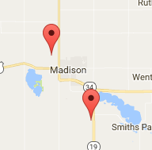

* Take some signal strength samples for both the 3G and 4G signals in your area
* Determine the boundaries, when does your signal strength increase vs decrease in your area
* Plot out a map showing these areas

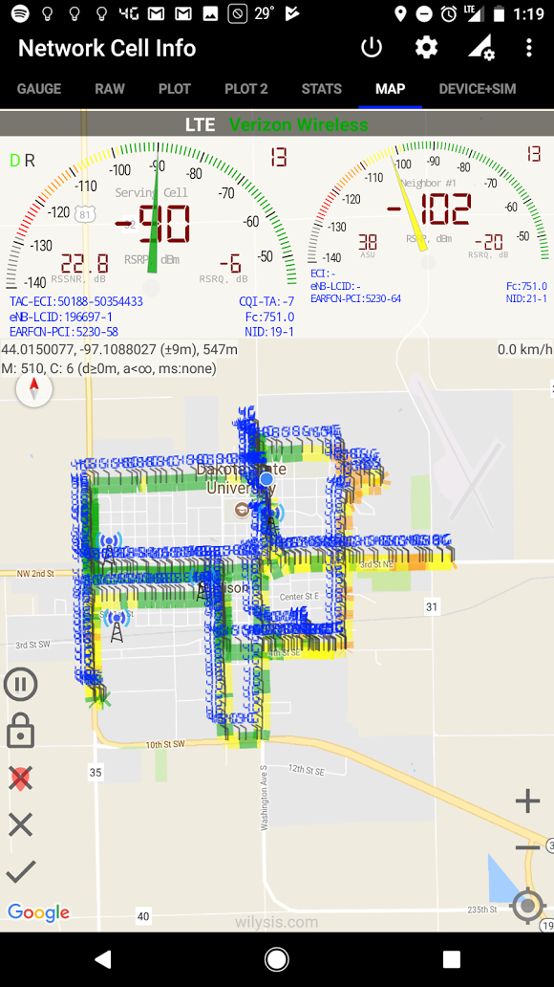

**Note:** I drove down the blue column at the central-top part of the map so the ‘sample’ labeles are overwhelming the actual map … that column was almost all green

* iPhones: Use Field Test Mode to find interesting information to help out with this lab. Android devices have many apps available in the Play Store to assist with getting this information. RSSI is one useful value for this lab.
* Submit a PDF file with your map showing the signal strength areas (heat map) and the base station locations

Discover some other info about the base stations and submit screenshots to show what you’ve found, such as:

What carriers are around? (Cellreception.com)

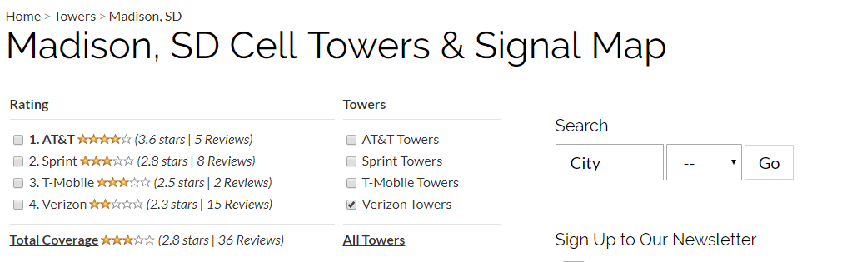

What ARFCN or frequency are you running on? Earfcon 5230 (

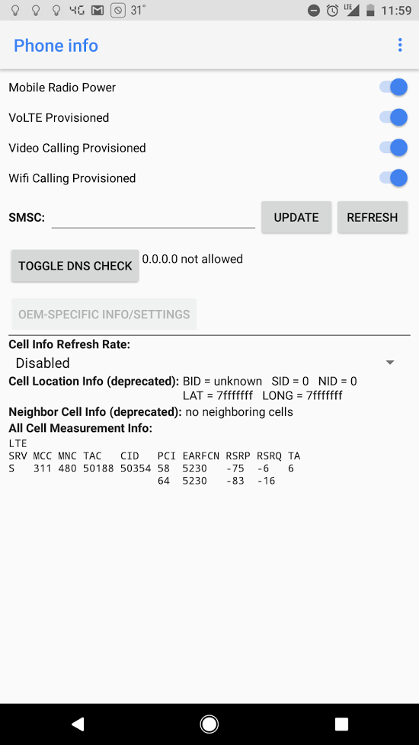

What’s the signal strength? (from Richardson dorm)

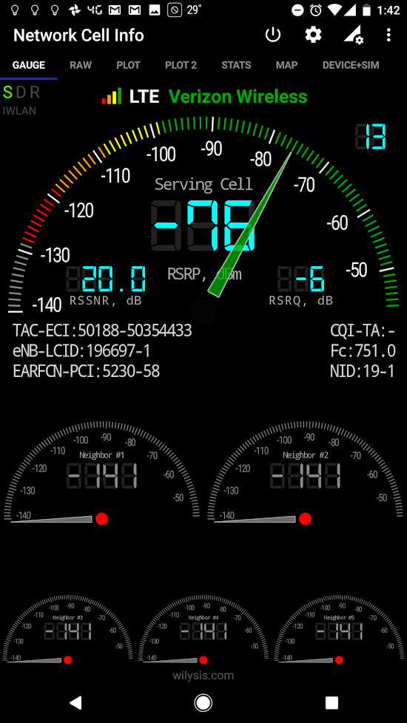

How many reselection candidates are there?

What are the BTS’s parameters? (Such as MCC, Cell ID, Location ID, etc)

*Since we aren’t using official tools for completing our samples, your results will not be 100% accurate, this is expected; don’t worry.

**Warning: If you just submit screenshots from OpenSignal.com (or other signal mapping websites), you’ll get a zero. The point is to take your own readings!!

***If you run into limitations for this lab, do not wait until the last minute to discuss it with me, let me know ASAP so we can work around any problems you have